Concordia University

**ENCS 6042 Communication Techniques for Innovation Process**

Project Mandate

**Organic Food Production and Farming - Cookfresh**

Submitted to:

**Professor Hussam Al Maleh**

Submitted By:

|  |  |
| --- | --- |
| **Student Name** | **Student ID** |
| Darshan Maniar | 40138514 |
| Devanshi Rajpara | 40164374 |
| Nithish Reddy Yalaka | 40164619 |
| Shvetkumar Patel | 40155533 |
| Tirtha Patel | 40156358 |

**Objective:**

With the outbreak of the pandemic and increase in demand for online delivery of food, we aim to improve the services of Meal-kit delivery through technology and innovation and by growing the food in a fresh and sustainable manner through organic farming.

**Stakeholders:**

* Raw Material Distributers
* People
* Employees of the Organization
* Warehouse Owner’s
* Local Super Marche
* Food Production Companies
* Logistics and Transportation Agency
* Local Farming Community

**Problem Statement**:

* Customer Side: Customers need customizable meal kits, not only the ones that are currently being offered by Meal kit delivery Companies.
* Production Side: To remove the dependency on other food production companies for growing fruits and vegetables, etc.

**Requirements:**

* Farming Estate
* Warehouse Building and Maintenance
* Maintaining the workforce (Production Associates, Food Packers, Farmers, Agriculturists, IT Team, Transportation Team, Supervisors)
* Healthy Environment Set-up

**Resources:**

* Raw Materials (packaging, production, and automation)
* Machinery
* Food Inspection Engineers
* Human Resources (Technical Team, Marketing, Automation, and Inventory)
* Plant Science Experts

**Exclusion**:

* Delivery of Cooked Food
* More to be added after consulting with the experts and Interviews.

**Scope**:

* Building an organic farm for growing food in a fresh and sustainable way.
* Improving the services of Meal-kit Delivery.
* Implementing and integrating the current supply chain the Enterprise Resource Planning Way.

**Assumptions and Constraints:**

* We will be able to maintain and deliver fresh food.
* Maintaining the food at government prescribed temperatures.
* Achieving the Target Market capital.
* Healthy Environment Set-Up

**Milestones:**

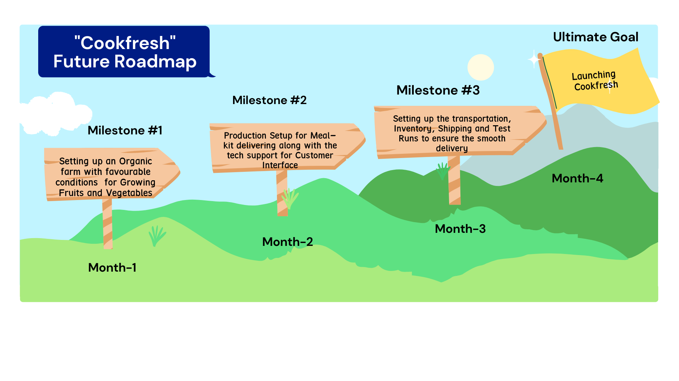

**Budget:**

To be decided based on the interviews and PMP experts

**Risks:**

* Health and Safety of the employees and Organization
* Employees following the guidelines while farming and packaging
* Issues with the food quality
* Maintaining the farm